**World Electrified Vehicle Sales (2013 Report)**

February 10th, 2014 by [Zach](http://evobsession.com/author/zshahan/)

[Republish Reprint](http://license.icopyright.net/rights/oneButtonTag.act?tag=3.15882?icx_id=2878" \t "_blank)

[**Republish Online**](http://license.icopyright.net/rights/republishOnlineServiceGroup.act?tag=3.15882?icx_id=2878)

[**Republish Offline**](http://license.icopyright.net/rights/republishOfflineServiceGroup.act?tag=3.15882?icx_id=2878)

[**Reprint**](http://license.icopyright.net/rights/reprintsServiceGroup.act?tag=3.15882?icx_id=2878)

[**Get Syndication Feed**](http://repubhub.icopyright.net/search.act?search=yes&showImmediate=yes&dateFilter=THIRTY_DAYS&featuredPublicationRestrictionString=p-15882&additionalPublication=15882)

First of all, let me note that these numbers below are not official and are surely a little imperfect (even more so than [US EV sales numbers](http://evobsession.com/electric-car-sales-increased-228-88-2013/)). However, they come from the most complete roundup of electrified vehicle (EV) sales I’ve seen. Frankly, I haven’t seen any other effort that tries to pull together EV sales in order to come to a global comparison.

The numbers again come from [Jose Pontes](http://www.ev-sales.blogspot.ch/2014/01/world-top-20-december-2013-special.html), as did the numbers for the [Europe electrified vehicle sales report](http://evobsession.com/europe-electrified-vehicle-sales-2013-report/) I just published. Check out the chart, the table, and my follow-up commentary:

[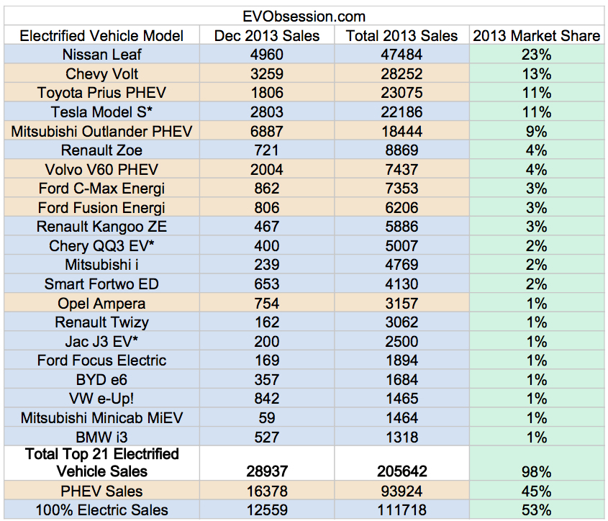](http://evobsession.com/world-electrified-vehicle-sales-2013/top-21-electric-vehicles-2013/)

Starting at the top, the [Nissan Leaf](http://evobsession.com/tag/nissan-leaf/) is the clear leader, with almost twice as many sales as the #2 [Chevy Volt](http://evobsession.com/tag/chevy-volt/). Though, given its rather limited availability outside the US, it’s impressive to see the Volt so high.

Building off of the success of the overall Prius brand, the [Toyota Prius PHEV](http://evobsession.com/tag/Toyota-Prius-PHEV/) comes in at #3, inches above the estimate of the high-demand, limited-supply [Tesla Model S](http://evobsession.com/tag/tesla-model-s/).

The [Mitsubishi Outlander PHEV](http://evobsession.com/tag/mitsubishi-outlander-phev/), after several months delay getting to market, stormed onto the scene at the end of 2013. [In its home country of Japan](http://evobsession.com/japan-electrified-vehicle-sales-2013-report/) (where it has been more available), it came it at #2 in 2013. Expect to see do quite well in 2014, and perhaps even rise above its #5 position. However, with the [BMW i3](http://evobsession.com/tag/bmw-i3/) and [VW e-Up!](http://evobsession.com/tag/vw-e-up/) just coming to market and starting off strong, expect to see them much higher on the list next year.

With strong sales in [Europe](http://evobsession.com/tag/europe/), the [Renault Zoe](http://evobsession.com/tag/renault-zoe/) and [Volvo V60 PHEV](http://evobsession.com/tag/volvo-v60-phev/) come in at #6 and #7, while the US-focused [Ford C-Max Energi](http://evobsession.com/tag/ford-c-max-energi/) and [Ford Fusion Energi](http://evobsession.com/tag/ford-fusion-energi/) follow close behind at #8 and #9. Ford and Renault, whose [Renault Kangoo ZE](http://evobsession.com/tag/renault-kangoo-ze/) van comes in at #10, are the only companies that crack the top 10 with two vehicles.